|  |
| --- |
| User guide : comment ajouter un cours à la base de données |

First of all, clic on the button “**Ajouter une séance**” in the top of the calendar.

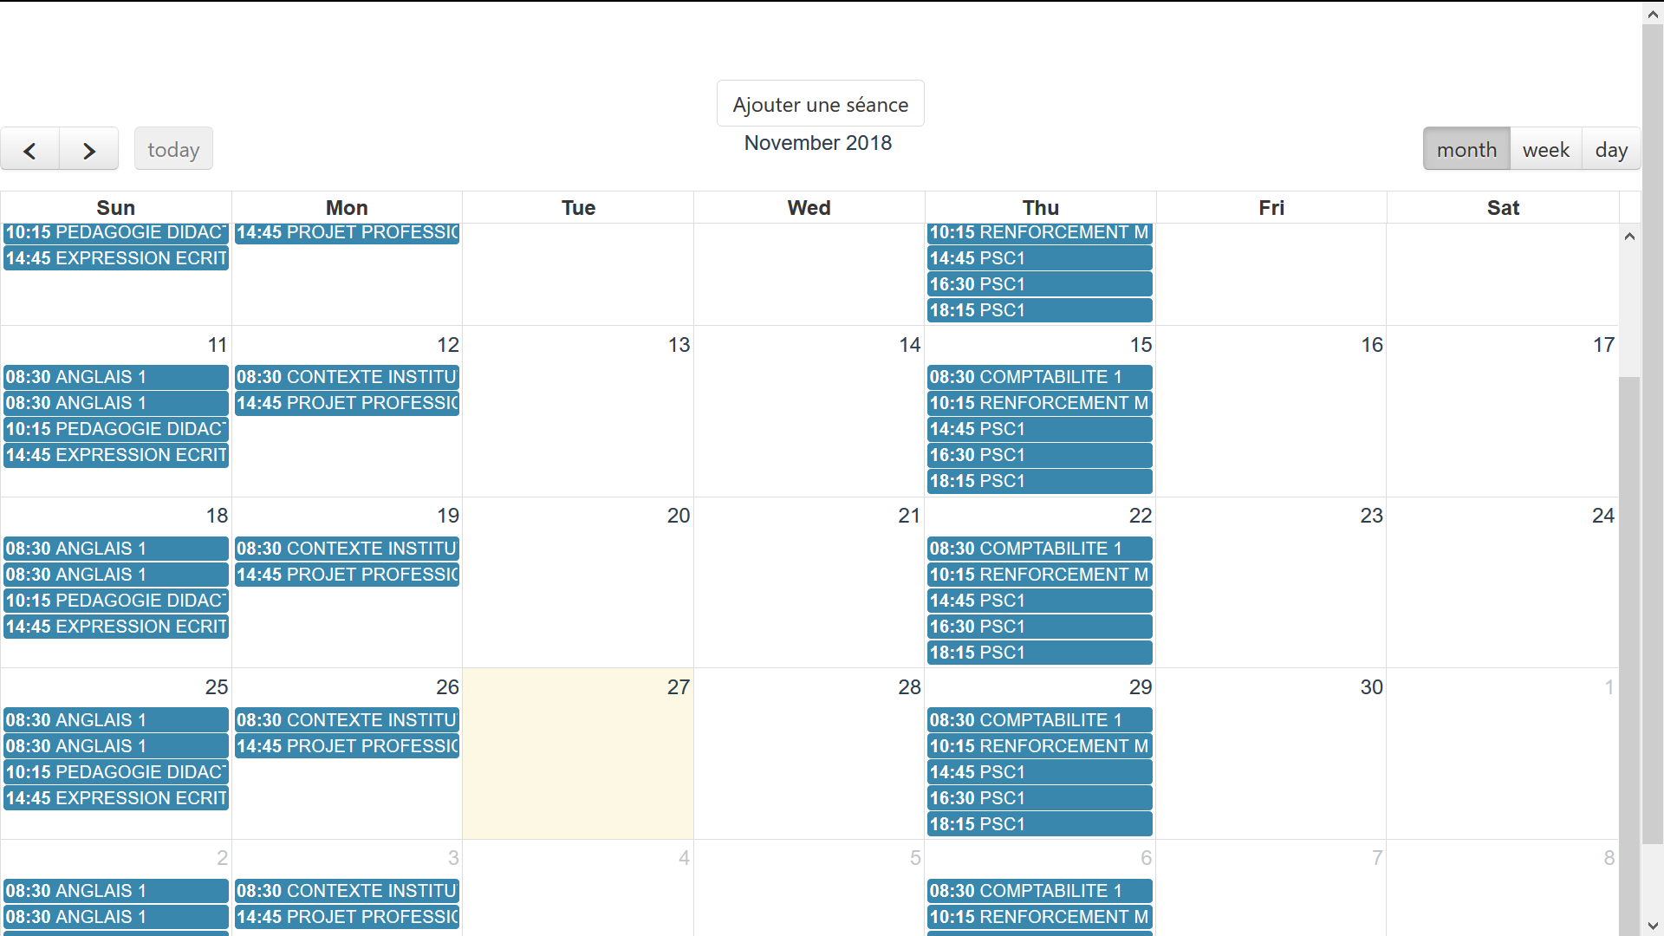

Now, a **form** should appear in the front of the calendar.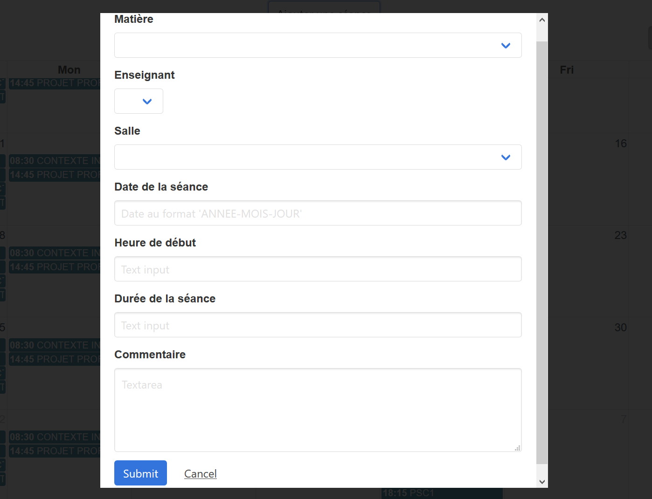

You now just have to fill all the fields and clic on “submit” to add the seance to the calendar !

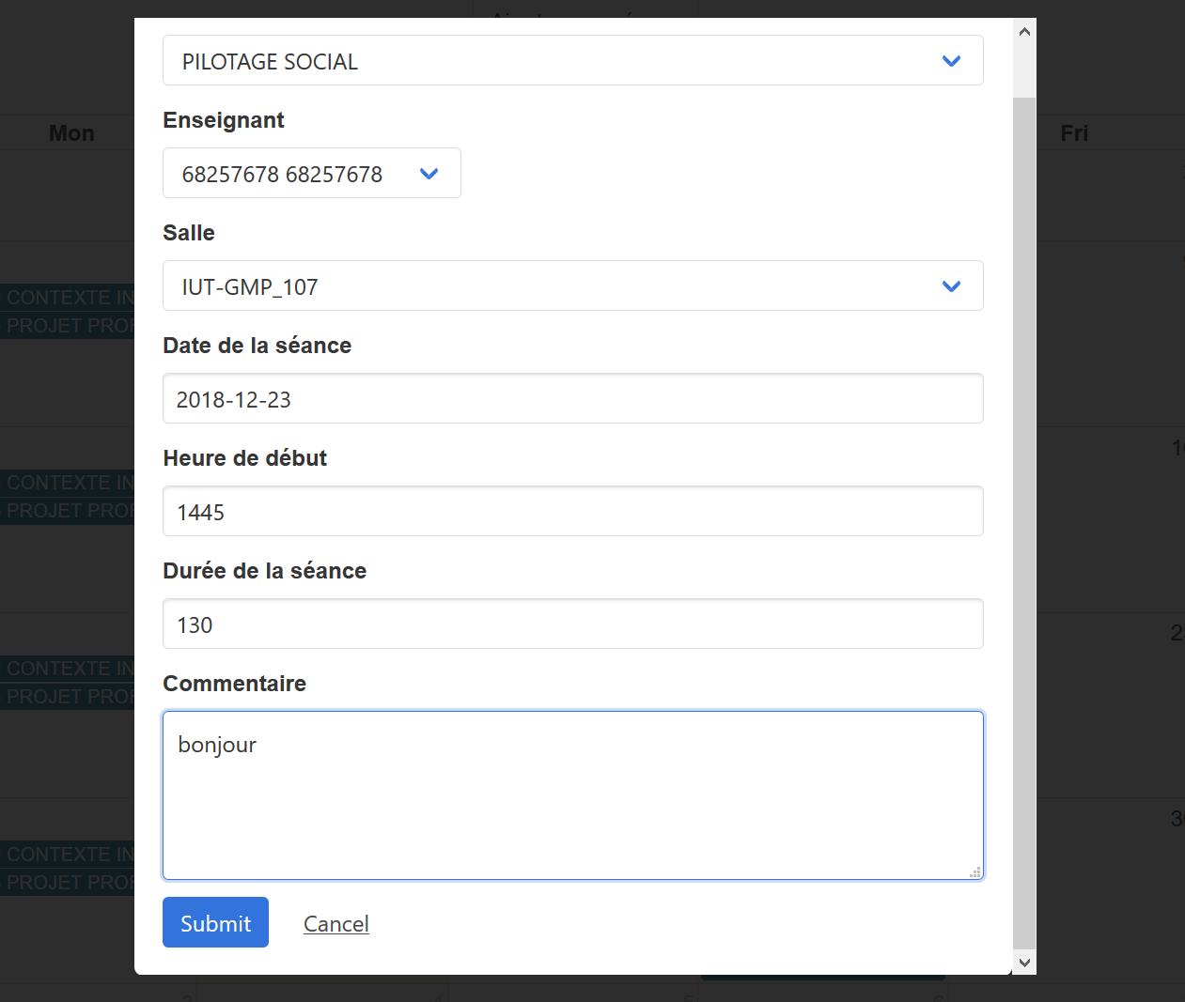

**[!]** Be careful to fill all the fields with the database standards.

Enjoy !